

**Subject: Data Visualisation**

**Name: Pradeep Kamble**

**Student ID: 10511829**

**Lecturer Name:**  **Basel Magableh**

**Assignment 1: Exploratory Analysis**

**Dataset: FIFA World Cup 2018 Match Statistics**

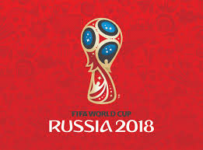 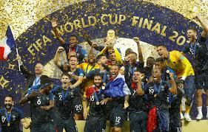

This Dataset Mainly focusing on what exactly happened in the World’s Biggest Sporting Event that is Football World Cup 2018.This dataset contains Statistics of 128 Matches with different types of records. The World cup was Scheduled between 14th June 2018 to 15th July 2018.The world cup was won by France for the second time. There are following components available in dataset.

1. Date: Match Date
2. Team: Playing Team
3. Opponent: Opponent Team
4. Goal Scored: Number of goals scored by this team
5. Ball Possession %: Amount of time ball was in control by the team
6. Attempts: Number of attempts to score goal
7. On-Target: Number of shots on-target
8. Off-Target: Number of shots that went off-target
9. Blocked: Number of opponent team's attempts blocked by the team
10. Corners: Number of corner shots used
11. Offsides: Number of off-side events
12. Free Kicks: Number of Free-kicks used
13. Saves: Number saves by the Goal keeper
14. Pass Accuracy %: Percentage of passes that reached the same team player as aimed
15. Passes: Total number of passes by the team
16. Distance Covered (Kms): Total distance covered by the team members in this game
17. Fouls Committed: Number of fouls committed by the team members
18. Yellow Card: Number of Yellow warning received
19. Red: Number of Red cards received
20. 1st Goal: When did the team score the 1st goal?
21. Round: Stage of the match
22. PSO: Was there a penalty shootout (PSO) in this match?
23. Goals in PSO: Number of goals scored in the Penalty shootout
24. Own goals: Number of own goals

NOTE: The dataset I taken from **Kaggle.com**

**Initial Analysis Questions:**

1. Which factors drive the football match result and their effects on the world cup?
2. Which teams are participated in FIFA world cup 2018?
3. Which Country scored the most goals whether it is European country, South American country, African country or Asian country?
4. Did any team member win man of the match?
5. How many factors affects the Goal Scoring percentage?

**Discoveries & Insights:**

Our analysis starts with plots of individual variables to assess distributions and data quality. As we progress, we build up multi-dimensional views for our analysis questions and Summarize what happened in FIFA World Cup 2018.

**1.Countries Which Are Participated in World Cup:**

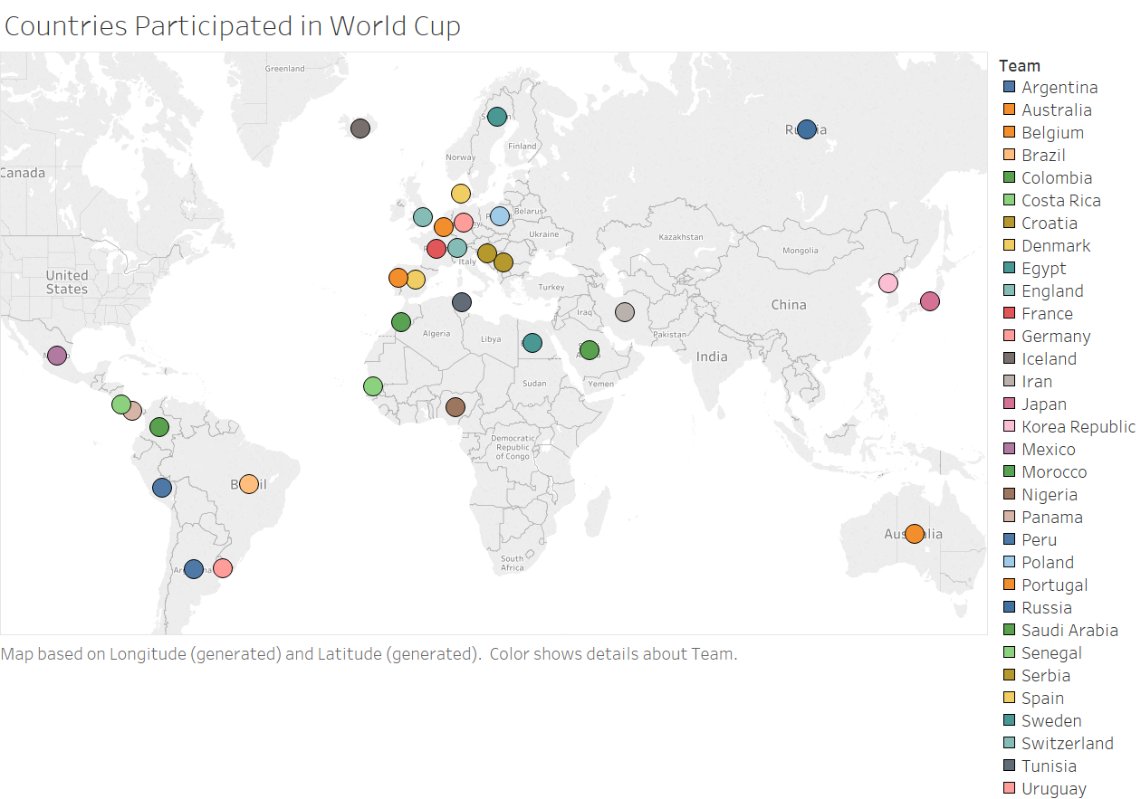

The Above **Symbol Map** Shows that 32 Countries (Teams) from all the over the World Participated in Football World Cup 2018 which are held in Russia. According to Symbol Map, the number of **European Countries** were more compare to other countries. The second most were **South American Countries** who participated in world cup. **African and Asian Countries** are less compared to others. The Mexico is only North American Country who become part of the world cup.

**2. Teams Who Qualified for Knockout Stage:**

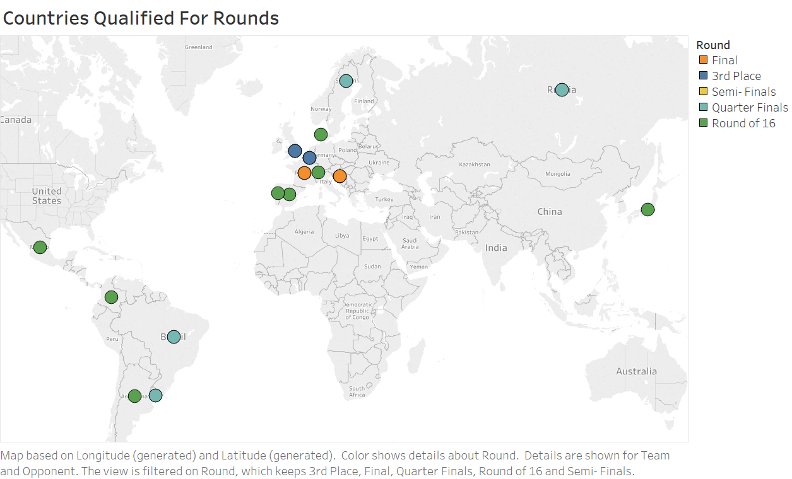

The Above **Symbol Map** Shows That there are 5 types of rounds namely as **Round of 16, Quarter Finals, Semi-finals, 3rd Place and Final**. After Group Stage only 16 teams are eligible for Knockout stage and other 16 teams were eliminated. There are 16 teams who played round of 16. After that, 8 teams played Quarterfinals. The matches are as follows: Belgium-Brazil, England-Sweden, Russia-Croatia and France-Argentina. Now the Belgium, Croatia, England and France played semi-final. And **Final** takes Place between France and Croatia this match was won by France. The Winner of 2018 World Cup Crowned by **France**.

**3. Total Numbers of Goals Scored by Each Team:**

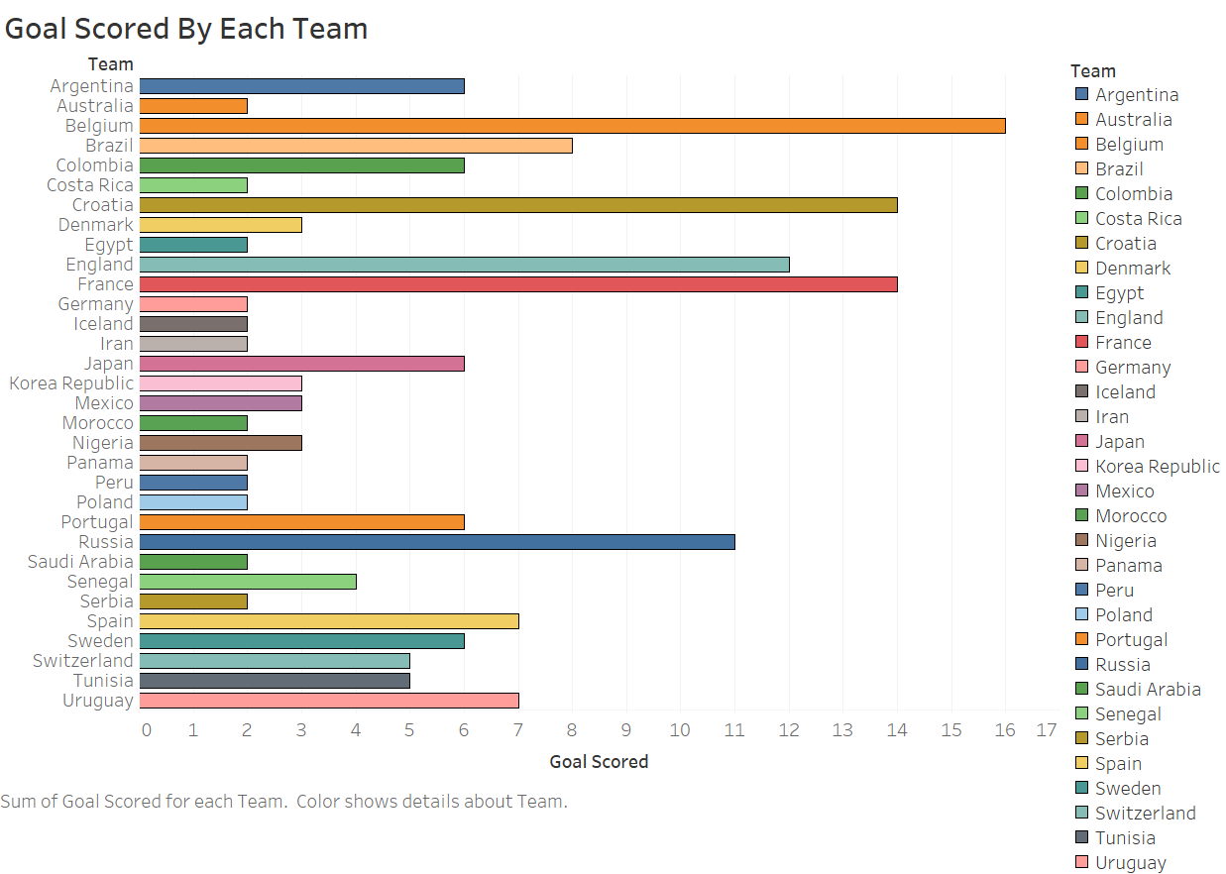

The Above **Horizontal Bar** Shows that total number of **Goals** Scored by **32 Teams** in each Round of the Tournament. According to the Graph, The Most number of Goals scored by **Belgium** that is **16**. And the lowest number of goals scored by 10 teams that is **2**. The finalists of world cup France and Croatia Scored 14 Goals are the second most. The host of the world cup **Russia** Scores **11 Goals** which are third highest. Both Spain and Brazil Scores 8 Goals Respectively.

**4.Most Own Goals and Penalty Goals:**

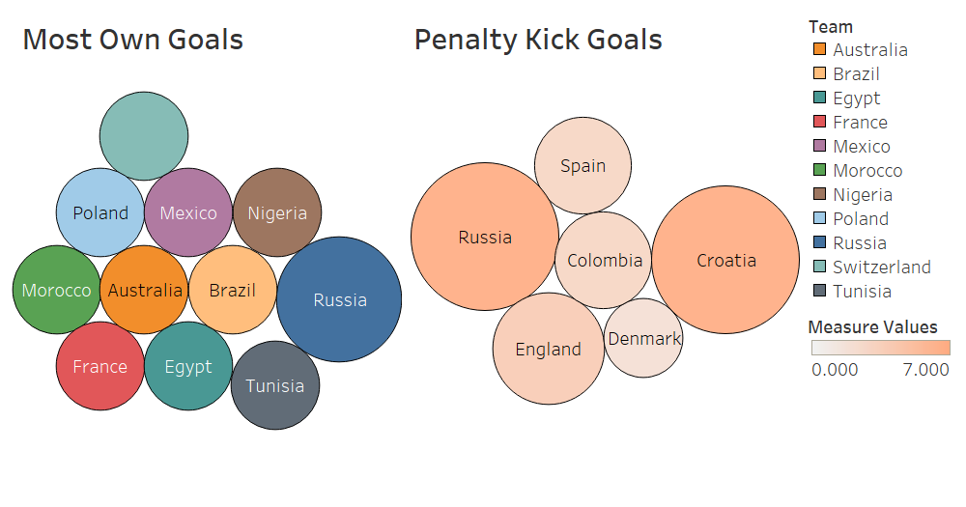

The Above **Packed Bubble Chart** Shows gives us information about **Own Goals** and **Penalty Kick** Goals Scored by Teams. In First bubble chart **Russia** is the team who scored most Own Goals that is **2**. And remaining teams scores only 1 own Goal. There are total 11 Teams who scored the own goal. In second bubble chart 6 Teams who Scores the goals from Penalty Spot. **Russia And Croatia** scored the **7 Goals** from Penalty Spot which are the highest among all. **Denmark** is team who scored only **2 Goals** from Penalty spot which are the lowest.

**5(a). Passing Accuracy and Ball Possession (AVG):**

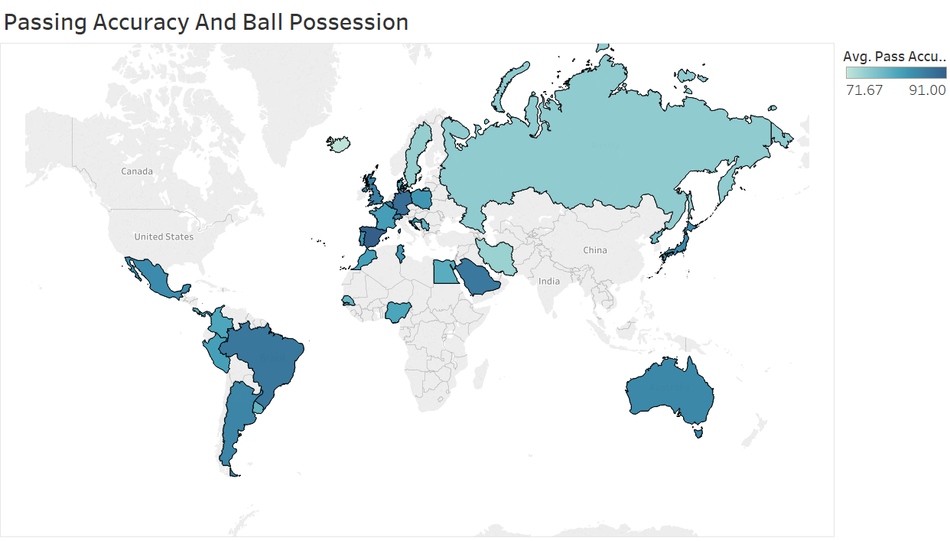

The Above **Regional Map** Shows that, **Average Passing Accuracy and Ball Possession** hold by each team. Passing Accuracy varies between 71% to 100% and Ball Possession Varies Between 25% to 75%. **Spain, Brazil, Germany and Saudi Arabia** having Best Passing Accuracy which is more than **85%**. On the other hand, **Iran, Iceland and Sweden** having lowest Passing Accuracy which is less than **75%.** Passing accuracy of team affect rate of Ball Possession rate. Same as above Spain, France and Argentina having highest number of Ball Possession. These factors can improve winning Performance of the team.

**5(b). Fouls Committed by Each Team Members:**

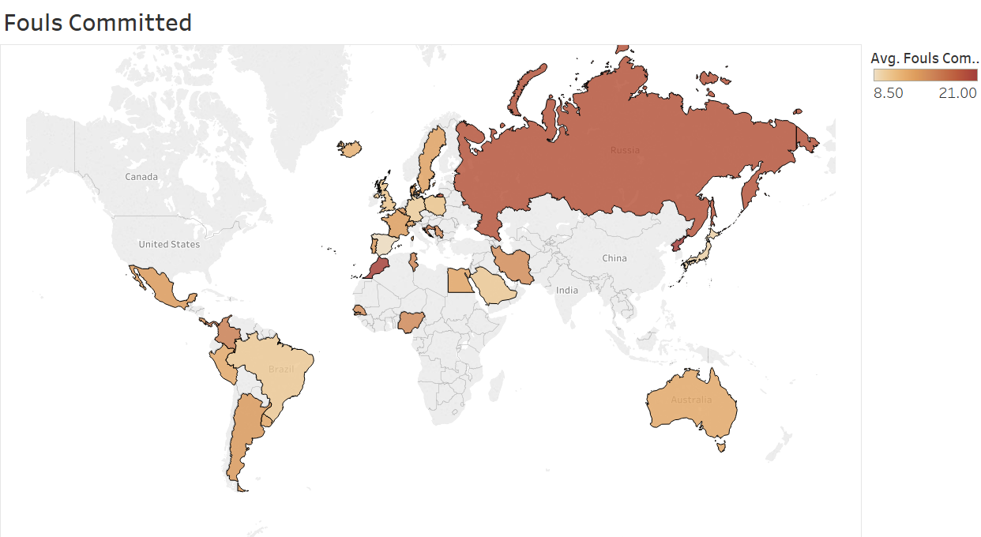

The Above **Maps** Shows that, Fouls Committed by each team member. We take average of fouls committed by teams. It varies from 8 to 21. The Map portraits that AVG fouls committed by **Russia, Iran and Morocco** are most than other countries. On contrast **Spain, Germany and Japan** have less number of fouls.

I conclude that, Team which have **highest Ball Possession and lowest Fouls** Won the match in world cup. example: France have Proper ratio of ball Possession and fouls that’s why they won the world cup.

**6. Corner Kick Taken by each Team:**

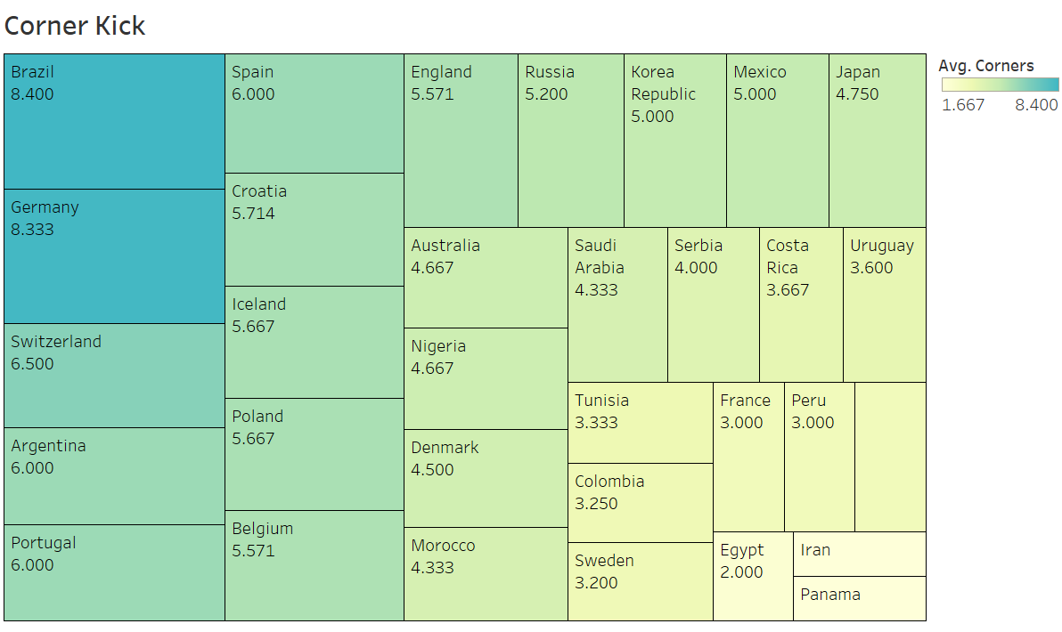

The above **Tree Map** Shows that Average **Numbers of Corner** taken by each team. From Tree Map we can easily visualize the data. As we shown above we can easily say that **Brazil and Germany** have More numbers of corner kick. The average of corners we take from 1 to 9. **Iran and Panama** have lowest number of Corner Kicks which is less than equal to 1. The Average of Corners varies with colour as we show in legend. The moderate number of corners taken by Poland, Belgium, Iceland and England. The more numbers of corners increasing Goal scoring Opportunity.

**7. Free kick Taken in Each Round of Tournament:**

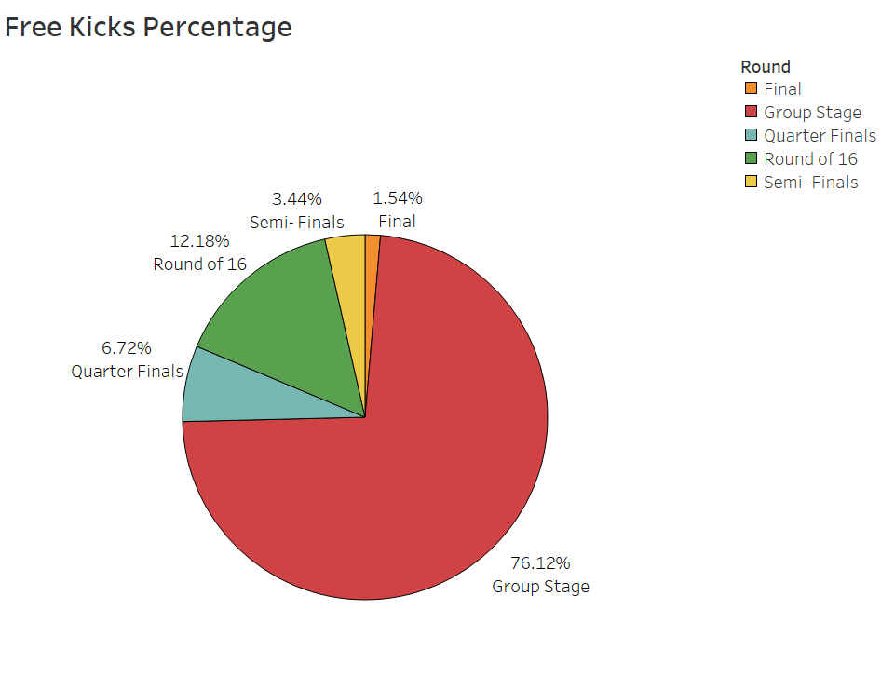

The Above **Pie Chart** Show **Percentage description of Free Kick** taken in each match of the world cup with their different stages of **round**. According to Pie chart we can easily determine that free kick percentage in **Group stage** are very high it around **76%.** The main reason behind that is number of matches were play more compare to other stages. The percentage of **Round of 16 (12.18)** is almost double than percentage of **Quarter finals (6.72)**. In Final the free kick Percentage was (1.54). We take different colour for different round as we shown in figure.

**8. Relationship between Attempt, On-Target, Off-Target and Total number of Goals Scored by each Team:**

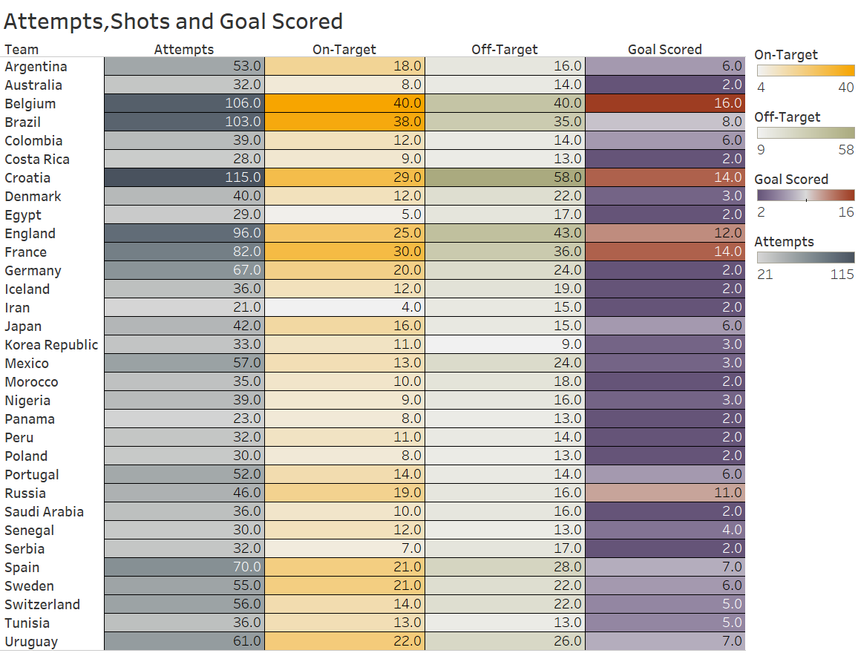

The Above **Text and Highlight Table** shows that Relationship between **Attempts, on-target and off-target to Total number of Goal** Scores. These above three factors have direct impact on the Goal scored. Since it is logical thing that more **numbers of attempts** result in **more numbers of goal scored** and vice versa. The Shot on target means Attempts which saved by Goalkeeper and around the Goalpost.

Off-target are the shots which does not cause any problems to Goalkeeper. If you have more of the numbers off-target shots the Probability is less to score the Goals. From the table we can easily determine that **Belgium** having more numbers of **attempts (106)** and **shot on-target (40)**. As a result, Belgium Scored **16 Goals** which is highest in Tournament. Both Croatia and France scores equal number of goals that is (14). But both have different number of attempts and almost similar number of shot on-target respectively. On other hand, 10 Teams only Scores two goals which are less just because they have less numbers of attempts and shot on-target. So, we summarize all the factors which affect the number of Goals scored using the Text table.

**9.Relation of Free kick and Corner with Goal scored and Rounds:**

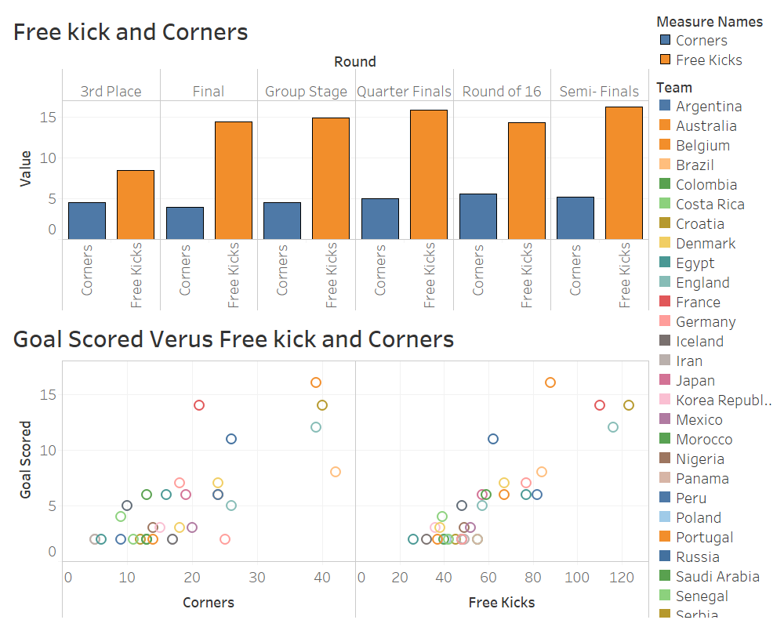

There are two Visualization I shown here: First is **Side by Side Bar Chart** which shows the how many total number of corners and free kick taken by teams in each round of the game. The **blue colour** indicates corner where as **yellow** indicates Free kicks as we shown in legend. From the bar chart we can directly conclude that in Quarter finals and semi finals the number of free kick is highest as compare to other round and also same in both. Highest numbers of corners taken by temas are most in Round of 16 its somewhere around 5 in Aveage. Also number of corners in 3rd place, Quarter and semi finals are almost same.

The second Visualization is **Scatter Plot** which shows Relationship between **Goal scored** with corner and free kicks. The basic principle is if you have most numbers of corners and free kick then more numbers of goals scored by team. In first plot **Belgium** have more numbers of corners **(38)** as a result they scored highest number of Goals **(16)**. In opposite **Iran** take lowest number of corners as a result they scored less Goals. In second plot **Croatia** take more numbers of free kicks **(123)** as a result they scored **14** goals in overall games behind Belgium. England is second most country which take free kicks (123) and finished third in highest number of goals.

**10.Summarization of Yellow card, Distance Covered, Attempts on each Matchday:**

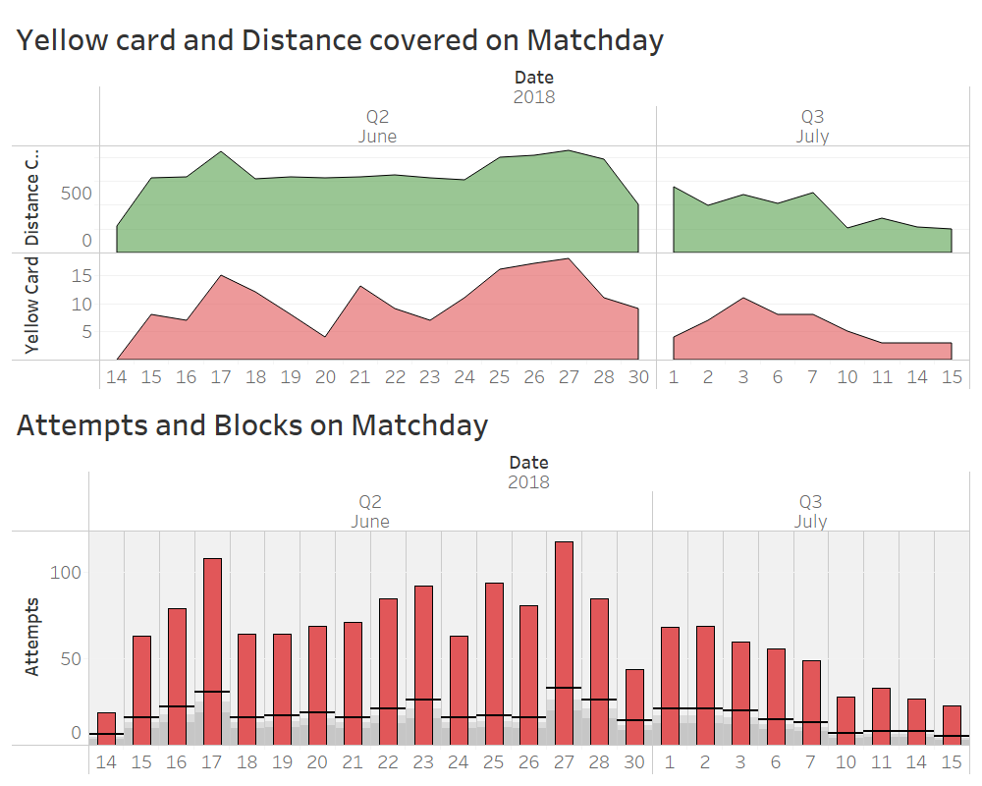

In our last Visualization we mainly focus on summary of some important factors that happened in each Matchday for example: **Yellow card, Distance Covered** by each player on each match. And total number of **Attempts and block shots**. Now we see one by one.

The first **Area Chart** mainly focusing on Yellow Card shown to players on each matchday and distance covered by each team on matchday. As from graph, we can easily determine that on **June 17th** matchday the distance cover by players are **maximum.** On the contrast, Distance Covered on **first** Matchday is very minimum. Now in July month **1st July** is the maximum in terms of distance covered. Next, Yellow Card is shown on **14th June** (1st Matchday) is 0. Whereas on 27th June there are 15 Yellow Cards are shown to players. In semi final and finals only 5 Yellow cards are shown to Players.

The Second Visualization is **Bullet Graph** which gives information about the number of attempts and blocked shots on each matchday. The **black line** shows the difference between Attempts and Blocks. The **lower** part below black line shows Attempts and the **upper** part above black line shows Block shots. On July 27th the total number of attempts are maximum. From **July 1st to 7th July** the number of attempts were stable. On July 14th the first day of the world cup the attempts are very less.

**Tableau Public Link for Publishing:**

Here I visualize all the data in tableau online and now I Publish the workbook on following link using Tableau Public:

<https://public.tableau.com/profile/pradeeep.kamble#!/vizhome/CA_01PradeepKamble_10511829/CountriesParticipatedinWorldCup?publish=yes>